**5th Food Science Frontier Research Forum**

**International University Consortium of Food Science and Nutrition**

**(First Announcement)**

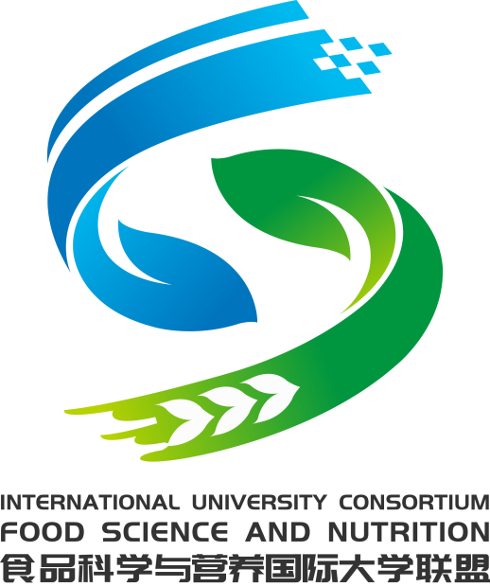

**5 November 2020**

The International University Consortium of Food Science and Nutrition (IUCoFSN) was first established in 2016 by Zhejiang Gongshang University in cooperation with the University of Leeds (UK), Massey University (New Zealand), Wageningen University (the Netherlands), and later joined in 2019 by Kyoto University (Japan), Guelph University (Canada), and University of Massachusetts (USA). Since its establishment, the Consortium has successfully held four conferences, attracting hundreds of experts and scholars from the food science and industry at home and abroad.

The International University Consortium of Food Science and Nutrition plans to hold the fifth annual event online with the theme of "Food Science and Nutrition Frontier Forum" on November 5, 2020. At this event, world-leading food scientists from consortium partners will report the latest research progresses in some frontier areas of food science and nutrition and share their views about the future direction of food science and nutrition research. The topics at the conference include food colloids and soft substances, food oral processing and sensory, molecular biology of nutrition, food digestion and nutrition, functional foods and food functional properties, and future foods. Colleagues and graduate students of food science and related disciplines as well as industrial researchers are very welcome to attend. Conference registration and online link will be announced in the next announcement.

**1. The conference agenda**

|  |  |  |
| --- | --- | --- |
| **Time** | **Title** | **Speaker** |
| 8:50-9:00 | Introduction | Prof. Jianshe Chen |
| 9:00-9:30 | Next-generation nutritionally fortified plant-based milks | Prof. David Julian McClements |
| 9:30-10:00 | Corn protein as a structuring agent in plant-based applications | Prof. Alejandro G. Marangoni |
| 10:00-10:30 | Biopolymer interactions during gastric digestion; new approaches to controlling the kinetics of nutrient release and absorption | Prof. Harjinder Singh |
| 10:30-11:00 | New lipid science in our inner ecosystem promoting our health | Prof. Jun Ogawa |
| 11:00-11:10 | Concluding remarks | Prof. Jianshe Chen |
| Break | | |
| 13:50-14:00 | Introduction | Prof. Mike Morgan |
| 14:00-14:30 | Appraising food: Beyong basic chemical analysis | Prof. Pingfan Rao |
| 14:30-15:00 | Water in water emulsion and their application in food. | Prof. Vincenzo Fogliano |
| 15:00-15:30 | Saliva, the protagonist in oral processing: Can we really simulate it? | Prof. Anwesha Sarkar |
| 15:30-16:00 | Our transition towards sustainable, plant-based diets:  Role of food structure | Prof. Peter Wilde |

**2. Organisers:**

The International University Consortium of Food Science and Nutrition Massey

Zhejiang Gongshang University (China)

**3. Conference format**

Presentation in English with on-site English translation.

**4. Invited speakers (in no particular order)\***

| **Photo** | **Speaker** | **Institute** |
| --- | --- | --- |
| http://spxy.zjgsu.edu.cn/UploadFiles/image/20160525/20160525144980348034.png | Prof. Mike Morgan | The University of Leeds, UK  （President of the International University Consortium of Food Science and Nutrition） |
| http://5b0988e595225.cdn.sohucs.com/images/20190627/00057523f72a445d869c0f0eb6cfd139.jpeg | Prof. David Julian McClements | University of Massachusetts, USA |
| http://spxy.zjgsu.edu.cn/UploadFiles/image/20160525/20160525191841134113.jpg | Prof. Harjinder Singh | Massey University, New Zealand |
| C:\Users\adin\Desktop\20年国际会议专家信息\peter wilde\PW pic.JPG | Prof. Peter James Wilde | Quadram Research Institute, UK |
| C:\Users\adin\Desktop\20年国际会议专家信息\Marangoni\Marangoni.jpg | Prof. Alejandro G. Marangoni | Guelph University, Canada |
| 微信图片_20200924141327.jpg | Prof. Vincenzo Fogliano | Wageningen University, the Netherlands |
| C:\Users\adin\AppData\Local\Temp\WeChat Files\12fb47a6d2505f7121ff925c3d883d3.png | Prof. Anwesha Sarkar | The University of Leeds, UK |
|  | Prof. Jun Ogawa | Kyoto University, JPN |
| http://spxy.zjgsu.edu.cn/uploadfiles/2013-1-5/2013151604871043.jpg | Prof. Pingfan Rao | Zhejiang Gongshang University, China |

**5. Conference chair**

Professor Jianshe Chen, Zhejiang Gongshang University , Secretary General of International University Consortium of Food Science and Nutrition.

**6. Contact:**

Ms. Dongmin and Ms. Jingxuan Guo ( Trista)

School of Food Science and biotechnology

Zhejiang Gongshang University

Xiasha, Hangzhou

Zhejiang Province 310018

P. R. China

Tele: 00(86) 571 28008921

Fax: 00(86) 571 28008900

Email: [dm901130@zjgsu.edu.cn](mailto:dm901130@zjgsu.edu.cn)